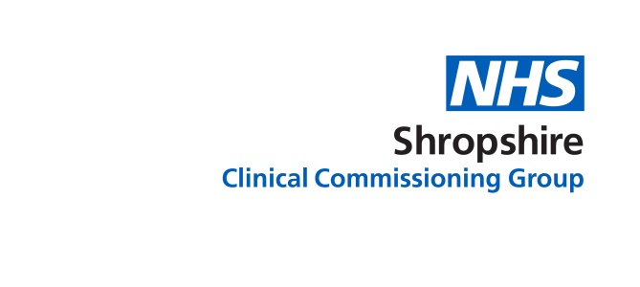
Information for Shropshire Patients Calling NHS111

When you get through to NHS111 it will be different from how your call used to be dealt with by Shropdoc. To help you make a call, here is a brief explanation of what happens when you dial NHS111.

Who will I be speaking to?
Your call will be answered by a highly trained advisor.

What will they do?
They will take you through a set of questions to help you get the right care, in the right place, at the right time.

What are these questions about?
- The questions follow a set pattern and your advisor will work through these with you.

- You might be asked questions that are not about the health issue you have called – but don’t worry. These questions have been designed to find if you could possibly have any other health issues that you might not be aware of. Some conditions also have a wide range of symptoms, whilst others may have a number of related and similar illnesses.

How long can this take?
It does depend on what you are calling about, but the questions help to build up a fuller picture of the illness or injury you are calling about. This could take up to 15 minutes, but please be patient and answer as many of the questions as you can.

What if my call is an emergency and I haven’t got time for all these questions?
The advisor can immediately send an emergency ambulance.

When I’ve answered the questions what happens next?
There are a number of actions the advisor may take:
- If your condition is life-threatening they can immediately send an emergency ambulance
- Pass you to a clinician, such as a GP, nurse, paramedic, dental nurse or mental health nurse, for a more detailed assessment and specific advice
- Book a non-emergency ambulance
- Provide information on self care, which is advice on what you can do to treat and help common medical conditions and complaints
- Advise you where to get medical help
- Refer you into the Out of Hours GP service for urgent telephone advice or a face-to-face appointment

Is there someone like a doctor or nurse I can actually talk to?

NHS 111 has a team called the Clinical Assessment Service, known as CAS, and this includes GPs, advanced nurse practitioners, specialist mental health and dental nurses, pharmacists, and paramedics who you will be able to speak to if you need to and they may call you back.

